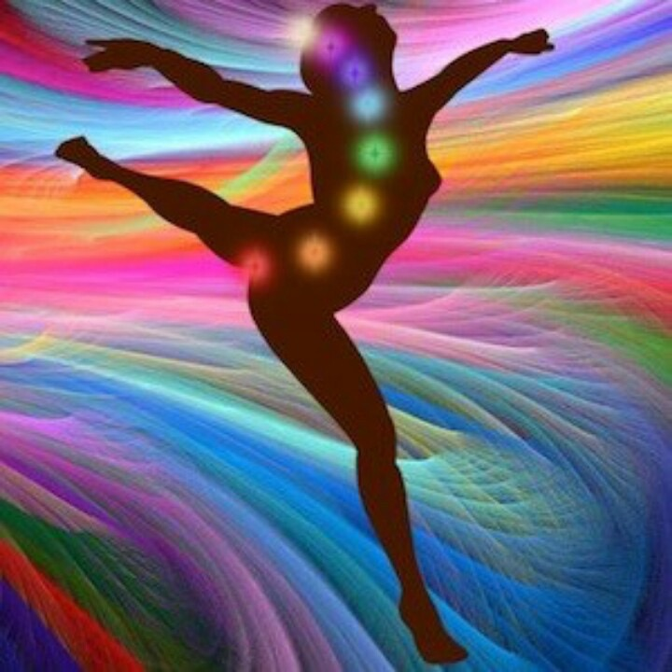

Sacred Centers’ Chakra Yoga Teacher Training:

Opening the Inner Temple

“The body is the vehicle; consciousness the driver.

Yoga is the path; the chakras are the map.

The core is the key and the moment is now.”

“The chakras represent the architecture of the human soul. As meeting points between mind and body, spirit and matter, the chakras form the yoke of yoga. As portals between the worlds, the chakras are the seven windows to the soul that connect the inner world with the outer.

Yoga is the spiritual language that opens these centers and brings us to the core consciousness of the divine within. Chakras are modulators of subtle energy and the goal is to free the prana to travel fully through the whole body: grounding your first chakra and rising through the core to the infinite consciousness of the crown.

In this training, yoga teachers and seasoned students will learn asanas through the lens of the chakra system. What distinguishes each of the seven portals to the soul? What postures do we use to open, stimulate, or relax various chakras? How do we read the body to understand the functioning of the chakras within? How do we combine opposites, such as opening and closing, holding and releasing, charging and discharging, to pump energy through the whole body-mind system? How do we incorporate breath, mantra and mudras into our chakra practice? How do we access and strengthen the core?

You will learn sun salute variations for each chakra, along with yoga and bioenergetic exercises for each chakra, along with chakra philosophy, pranayama, mantras, guided meditation and more.”

Presenter

Melanie Fawer

Sacred Centers Chakra Teacher

RYT 500 Hours & YACEP

KPJ Certified Ashtanga Yoga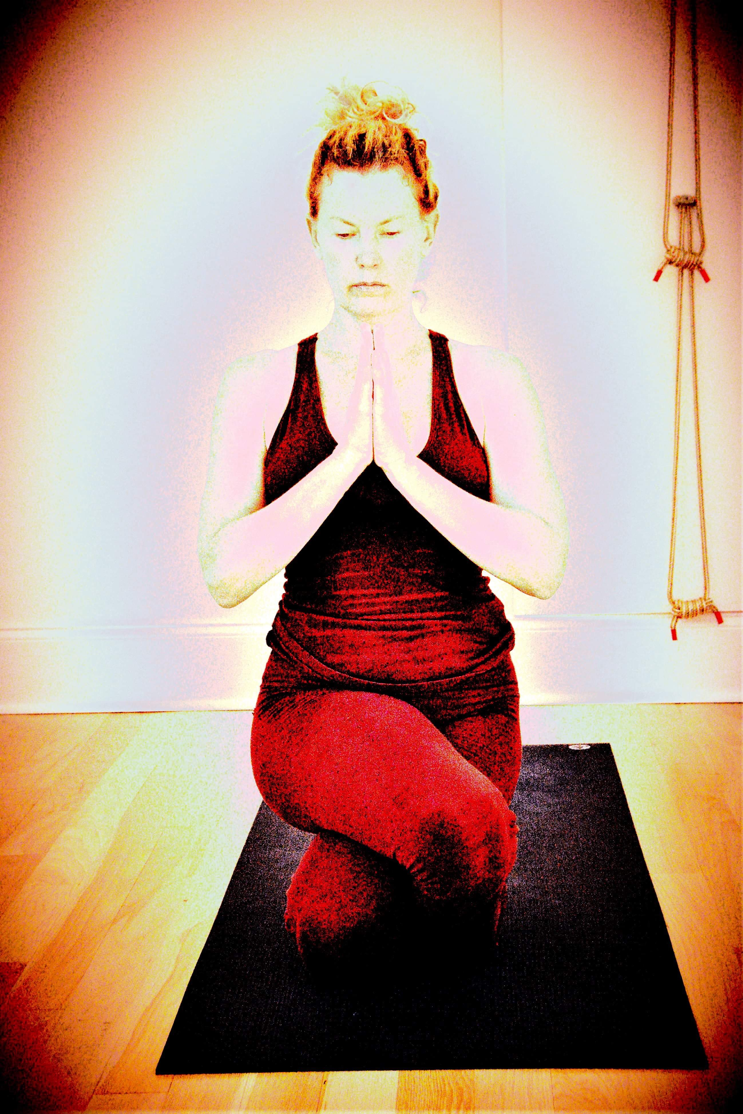

Melanie has been a yoga practitioner for over 26 years and a student of the subtle body for the last ten years as a co-heart of the Sacred Centers Certification Program, the focused chakra studies program of Anodea Judith, PhD. Melanie also considers herself an amateur psychologist. She earned her B.A. Psychology from New York University and maintains consistent on-going studies, a student of Schema therapy specifically since 2015.

Whether you want to unravel your conditioning, heal from trauma, find greater joy in your life and live to your fullest potential, Melanie believes we must come at the process from multiple angles. A must is understanding the seven portals of the subtle body that explain how to curate heaven here on earth.

While yoga begins the process of putting us back into our body and opening us to the mind/body matrix, the chakra system takes us necessarily deeper as we learn to understand and manage the human aspects of our beings to avoid spiritual, emotional and psychological bypassing.

Bio-energetics work in tandem helping to “take the issues out of the tissues” while psychotherapy focuses us unraveling the power of the Schema; patterns of maladaptive beliefs and patterns that developed in childhood yet continue to inform the choices we make every day. The chakra system unites all of these processes together yoking them into a greater whole.

Melanie owns Ashtanga Yoga Room, in New Orleans, Louisiana, teaching daily yoga classes in alignment and energy based Ashtanga. She leads annual intensives, “Yoga and Chakra Immersions,” and this summer kicks of “Soul Peel” in Nicaragua, the most natural step in bringing

people to the most insightful levels of self discovery and

healing in a place of pure beauty using nature, art, dance, surf, yoga, bio-energetics, and the chakra system

Anodea Judith’s Sacred Centers 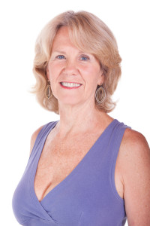

“Sacred Centers is a teaching organization founded by Anodea Judith, PhD., in 1999. It quickly became a community of individuals (Co-Hearts) dedicated to deeper personal growth on all levels, and diverse cultural healing and evolution.

The time spent with Sacred Centers , whether through certification training, a live workshop, a virtual tele-class, or an intensive retreat, maintains itself effortlessly in our daily lives, staying with us and enhancing the sacred within. Sacred Centers’ “kin-doms" become self-organizing centers for the coalescence of consciousness, illuminating the sacred web of life for the purpose of bringing together the imaginal cells of the emerging paradigm.

Anodea’s goal has always been to promote sacred knowledge for the transformation of individuals and culture. The name Sacred Centers refers to the divine center within each one of us, to the seven major energy centers known as chakras, and to the need to be centered in the sacredness of our daily lives. The Vision of Sacred Centers is first and foremost to restore connection to the sacred. Too many of us have lost touch with the invaluable resources we hold within.

By re-learning to ground and center yourself, by returning to spiritual practices such as yoga, meditation, healing, ritual, trance, poetry, art, music, and dance, and by allowing ourselves to focus within, we can achieve deeper contact, understanding, and living. We can enjoy the benefits of a powerful reconnection with ourselves, each other, and the grand web of life.

At Sacred Centers, we feel that training yourself to dig deep into the within and tapping into the sacred space there, we inform all other actions in the mundane world, rendering them them more meaningful and effective in our everyday lives.”

DATES & TIMES

Friday, March 13 - Monday, March 16

Friday, March 13; 9:00am - 5:00pm

Saturday, March 14: 11:00am - 7:00pm

Sunday, March 15: 11:00am - 7:00pm

Monday, March 16: 9:00am - 5:00pm

INVESTMENT

$399; early bird $345 by February 15

Venmo: Melanie Fawer

Checks made out to: Melanie Fawer

Mail to: 2521 Jena St. 2nd floor, New Orleans, LA 70115

Credit cards subject to 3% cc fee.

www.ashtangayogaroom.com

CREDITS

Sacred Centers Certification Program (SCCP)

Yoga Alliance Continuing Education Program (YACEP)